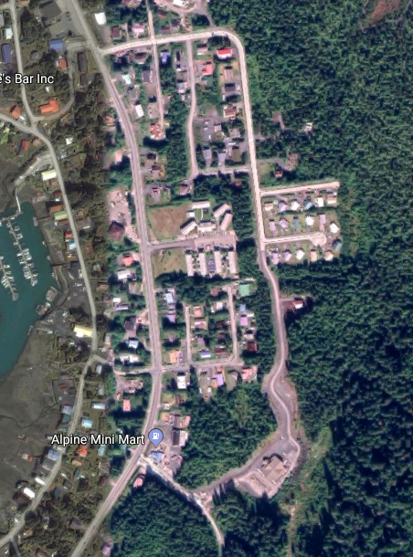

Pine Street

Etolin Avenue

All Medical Clinic access is via Wood Street

Wood Street

No pedestrian or vehicle access to clinic beyond this point

Hospital construction zone

Medical clinic