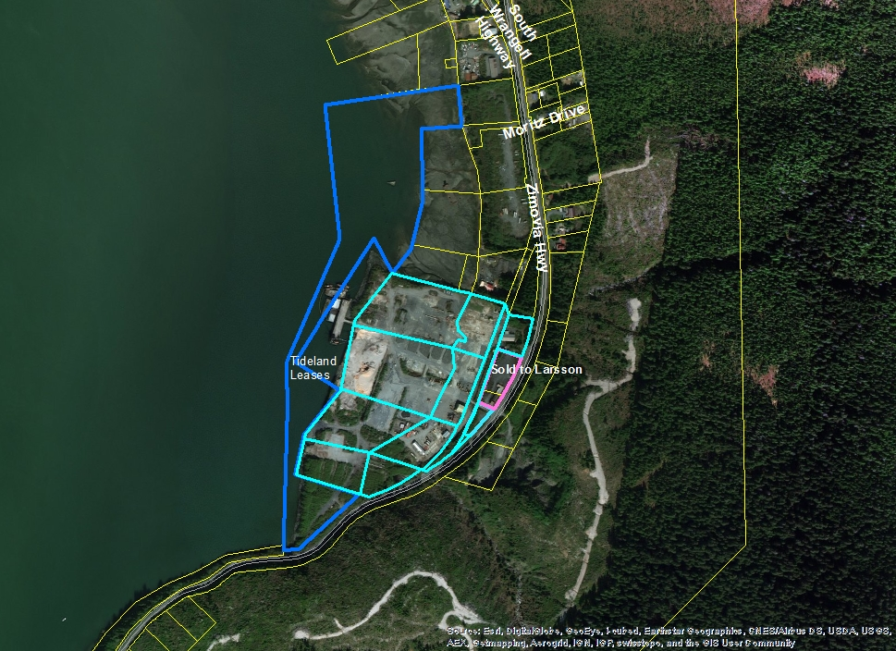

Dark blue line identifies tidelands
Light blue line identifies the upland lots now owned by the City and Borough of Wrangell
Pink lines show the two lots Mrs. Buhler sold previously to private owner.

