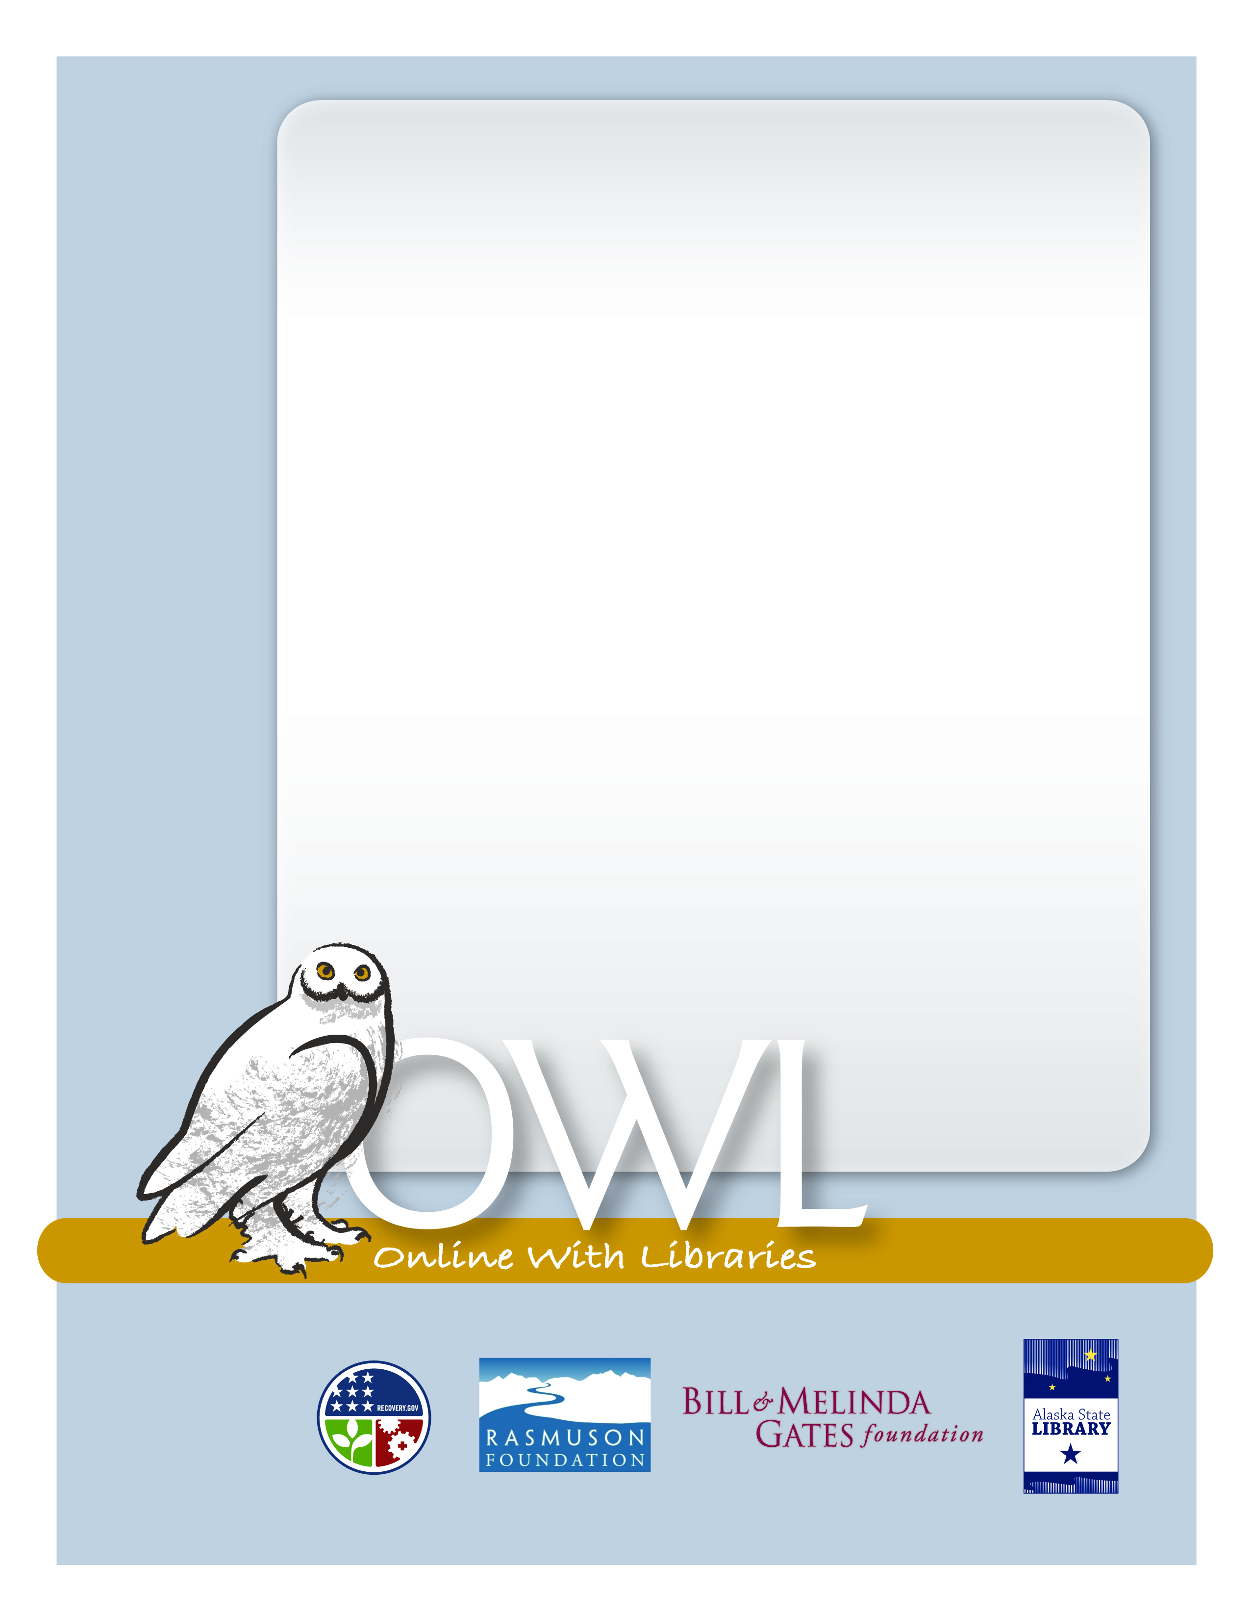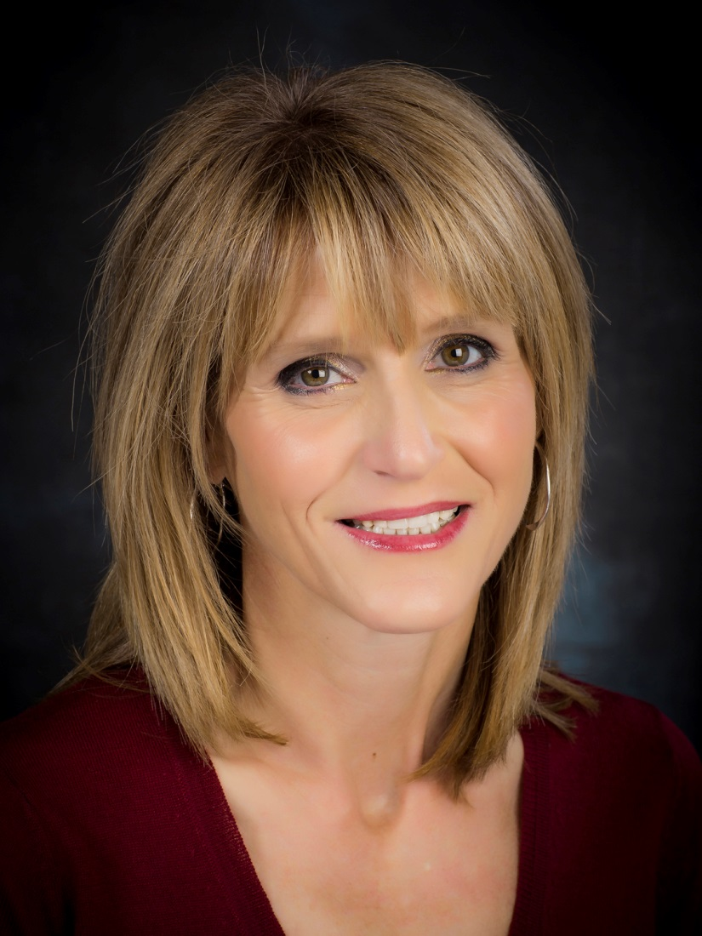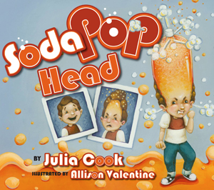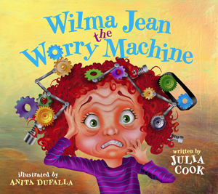

Monday, September 22

5:00 to 6:00 PM

A Free Family Event, Statewide.

Award winning children’s book author, Julia Cook, will visit with children and families throughout the state on Monday, September 22nd.  If you would like to get to know her and her work can visit her website www.juliacookonline.com

Julia has presented in more than 800 schools across the country, and published more than three-dozen children’s books.  The goal behind all of Julia’s books and efforts is to actively involve young people in her fun and creative stories and teach them to become life-long problem solvers. Her colorful and engaging titles like, “My Mouth is a Volcano,” “Personal Space Camp,” and “A Bad Case of Tattle Tongue” tackle issues in a way that is fun for children and their parents.

Julia’s visit is sponsored through a grant from the Alaska Mental Health Trust and in partnership with the UAA Center for Human Development.

Help your library win! The Library with the highest attendance for this visit will receive a set of Julia’s books to add to their collection.

VIDEOCONFERENCE

Julia Cook:

Virtual Authors Visit